**Part 1:**

**Step 1:  Create an ABAP WebDynpro component with a method to share with other WD apps.**

ABAP DynPro Name: ZWD_CMP_SHARED_POPUPS

[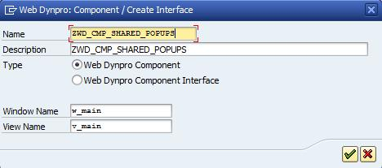](https://blogs.sap.com/wp-content/uploads/2013/04/p_205924.jpg)

**Step 2:  Create an attribute of the COMPONENTCONTROLLER called POPUP_WINDOW.**

***[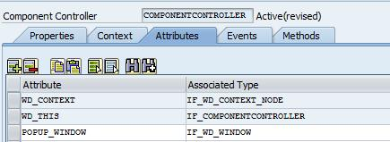](https://blogs.sap.com/wp-content/uploads/2013/04/p_206024.jpg)***

Then create a context node and attribute on the component controller context as follows:

***[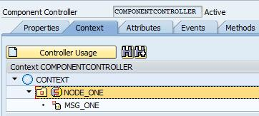](https://blogs.sap.com/wp-content/uploads/2013/04/p_206025.jpg)***

*Make sure to select the check box “Interface Node” on the node attributes:

***[](https://blogs.sap.com/wp-content/uploads/2013/04/p_206026.jpg)***

*Select STRING for the type of attribute for MSG_ONE

**Step 3:  Create a new view called V_POPUP_OK and a new window called W_POPUP_OK.**

Set Width (400px) and Height (300px) properties on the ROOTUIELEMENTCONTAINER of the View

Then embed the View onto the Window:

[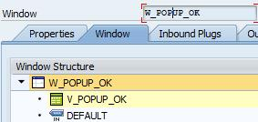](https://blogs.sap.com/wp-content/uploads/2013/04/p_206027.jpg)

On the views context, drag (map) the node “NODE_ONE” from the component controller context to the view context:

[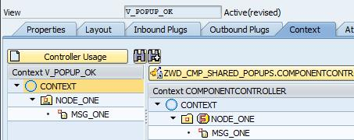](https://blogs.sap.com/wp-content/uploads/2013/04/p_206028.jpg)

On the layout of this view, create a TextView element and bind its text to the MSG_ONE attribute:

[](https://blogs.sap.com/wp-content/uploads/2013/04/p_206029.jpg)

**Step 4:  Create a method called POPUP_OK (check as Interface) on the Component Controller.**

***[](https://blogs.sap.com/wp-content/uploads/2013/04/p_206030.jpg)***

method popup_ok .

  data lo_window_manager type ref to if_wd_window_manager.  
  data lo_api_component  type ref to if_wd_component.  
  data lo_window         type ref to if_wd_window.  
  data current_action    type wdapi_action.

  lo_api_component  = wd_this->wd_get_api( ).  
  lo_window_manager = lo_api_component->get_window_manager( ).

  call method lo_window_manager->create_window  
    exporting  
      window_name          = ‘W_POPUP_OK’  
      title                = ‘Confirmation’  
      message_display_mode = if_wd_window=>co_msg_display_mode_selected  
      close_in_any_case    = abap_true  
      button_kind          = if_wd_window=>co_buttons_yesno  
      message_type         = if_wd_window=>co_msg_type_none  
      default_button       = if_wd_window=>co_button_no  
      close_button         = abap_false  
      modal                = abap_true  
    receiving  
      window               = wd_this->popup_window.

  wd_this->popup_window->set_window_position( position = if_wd_window=>co_center ).  
  wd_this->popup_window->open( ).  
  wd_this->popup_window->subscribe_to_button_event(  
                                     button = if_wd_window=>co_button_yes  
                                     action_name = ‘YES’  
                                     action_view = lo_api ).  
  wd_this->popup_window->subscribe_to_button_event(  
                                     button = if_wd_window=>co_button_no  
                                     action_name = ‘NO’  
                                     action_view = lo_api ).

  free lo_window_manager.  
  if sy–subrc ne 0.  
  endif.  
  free lo_api_component.  
  if sy–subrc ne 0.  
  endif.

endmethod.

**Step 5:  Create another ABAP WebDynpro application to call this shared popup.**

***[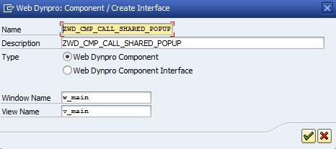](https://blogs.sap.com/wp-content/uploads/2013/04/p_206032.jpg)***

On the Used Components tab, add an entry for your ZWD_CMP_SHARED_POPUPS component

[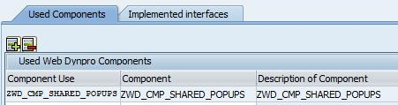](https://blogs.sap.com/wp-content/uploads/2013/04/p_206033.jpg)

**Step 6:  In the main view, create a Component Usage for both the Shared Component and the Shared Component’s Interface Controller.**

***[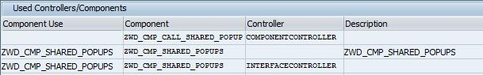](https://blogs.sap.com/wp-content/uploads/2013/04/p_206034.jpg)***

Select the context tab and you will see the context of the shared component controller’s context.  Drag (bind) the node “NODE_ONE” to your view as follows:

[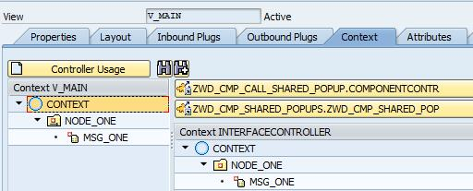](https://blogs.sap.com/wp-content/uploads/2013/04/p_206035.jpg)

*This binding is possible because we made the node an “Interface Node”.

**Step 7:  In the same main view, create two event handlers for the popup responses.**

***[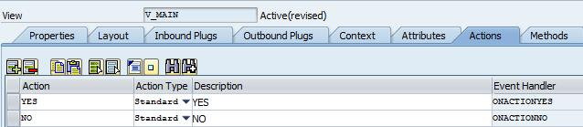](https://blogs.sap.com/wp-content/uploads/2013/04/p_206036.jpg)***

*you can choose your own code to add in these events (if any at all).

**Step 8:  Add the following code to the hook method: WDDOINIT.**

method wddoinit .

* Use the Wizard to Set a Value of MSG_ONE which the Popup will Display  
  data lo_nd_node_one type ref to if_wd_context_node.  
  data lo_el_node_one type ref to if_wd_context_element.  
  data ls_node_one type wd_this->element_node_one.  
  data lv_msg_one type wd_this->element_node_one–msg_one.

  lo_nd_node_one = wd_context->get_child_node( name = wd_this->wdctx_node_one ).  
  lo_el_node_one = lo_nd_node_one->get_element( ).  
  lv_msg_one = ‘Are You Sure You Wish To See The Houston Dynamo Play Soccer?’.  
  lo_el_node_one->set_attribute( name =  `MSG_ONE` value = lv_msg_one ).

* Use the Wizard to Instantiate the Used Component  
  data lo_cmp_usage type ref to if_wd_component_usage.  
  lo_cmp_usage = wd_this->wd_cpuse_zwd_cmp_shared_popups( ).  
  if lo_cmp_usage->has_active_component( ) is initial.  
    lo_cmp_usage->create_component( ).  
  endif.

* Use the Wizard to call the method of the Used Component  
  data lo_api type ref to if_wd_view_controller.  
  data lo_interfacecontroller type ref to ziwci_wd_cmp_shared_popups .  
  lo_api = wd_this->wd_get_api( ).  
  lo_interfacecontroller = wd_this->wd_cpifc_zwd_cmp_shared_popups( ).  
  lo_interfacecontroller->popup_ok( lo_api = lo_api ).

endmethod.

That’s it…  Test your application to see if it correctly calls the shared component and displays the popup and also displays the message you saved in the mapped context attribute.

[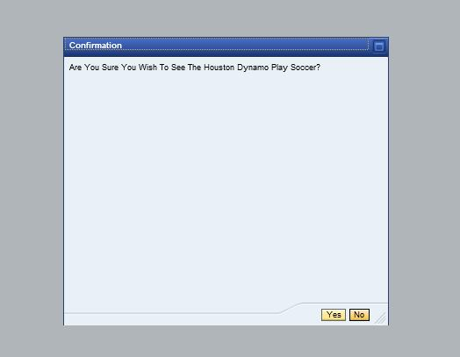](https://blogs.sap.com/wp-content/uploads/2013/04/p_206037.jpg)